**React 13**

**Aim:** Create a React App named “bloggerapp” in with 3 components.

1. Book Details
2. Blog Details
3. Course Details

Implement this with as many ways possible of Conditional Rendering.

**BookDetails.js:**

import React from "react";

function BookDetails() {

  const books = [

    { id: 1, title: "React Made Easy", author: "John Doe" },

    { id: 2, title: "Mastering JS", author: "Jane Smith" },

    { id: 3, title: "CSS Secrets", author: "Lea Verou" },

  ];

  return (

    <div className="card">

      <h2>📘 Book Details</h2>

      <ul>

        {books.map((book) => (

          <li key={book.id}>

            <strong>{book.title}</strong> — {book.author}

          </li>

        ))}

      </ul>

    </div>

  );

}

export default BookDetails;

**BlogDetails.js:**

import React from "react";

function BlogDetails() {

  const blogs = [

    { id: "b1", title: "Why React is Awesome", date: "2025-08-01" },

    { id: "b2", title: "Understanding Conditional Rendering", date: "2025-07-20" },

  ];

  return (

    <div className="card">

      <h2>✍️ Blog Details</h2>

      {blogs.length > 0 ? (

        <ul>

          {blogs.map((blog) => (

            <li key={blog.id}>

              <strong>{blog.title}</strong> — <em>{blog.date}</em>

            </li>

          ))}

        </ul>

      ) : (

        <p>No blogs available.</p>

      )}

    </div>

  );

}

export default BlogDetails;

**CourseDetails.js:**

import React from "react";

function CourseDetails() {

  const courses = [];

  // Conditional rendering using ternary operator

  return (

    <div className="card">

      <h2>🎓 Course Details</h2>

      {courses.length > 0 ? (

        <ul>

          {courses.map((course, index) => (

            <li key={index}>{course}</li>

          ))}

        </ul>

      ) : (

        <p>No courses available at the moment.</p>

      )}

    </div>

  );

}

export default CourseDetails;

**App.js:**

import React, { useState } from "react";

import BookDetails from "./components/BookDetails";

import BlogDetails from "./components/BlogDetails";

import CourseDetails from "./components/CourseDetails";

import "./App.css";

function App() {

  const [activeComponent, setActiveComponent] = useState("book");

  // Using element variable for conditional rendering

  let content;

  if (activeComponent === "book") {

    content = <BookDetails />;

  } else if (activeComponent === "blog") {

    content = <BlogDetails />;

  } else {

    content = <CourseDetails />;

  }

  return (

    <div className="app">

      <h1>📚 BloggerApp</h1>

      <div className="button-bar">

        <button onClick={() => setActiveComponent("book")}>Book Details</button>

        <button onClick={() => setActiveComponent("blog")}>Blog Details</button>

        <button onClick={() => setActiveComponent("course")}>Course Details</button>

      </div>

      {/* Rendering content based on condition */}

      {content}

    </div>

  );

}

export default App;

**App.css:**

body {

  font-family: "Segoe UI", sans-serif;

  background: #f4f6f9;

  margin: 0;

  padding: 0;

  color: #333;

}

.app {

  padding: 2rem;

  text-align: center;

}

h1 {

  color: #0078d7;

}

.button-bar {

  margin-bottom: 20px;

}

button {

  padding: 10px 20px;

  font-size: 1rem;

  margin: 5px;

  border: none;

  border-radius: 6px;

  background-color: #0078d7;

  color: white;

  cursor: pointer;

}

button:hover {

  background-color: #005ea6;

}

.card {

  background: #fff;

  max-width: 600px;

  margin: auto;

  padding: 20px;

  border-radius: 12px;

  box-shadow: 0 8px 20px rgba(0, 0, 0, 0.1);

  text-align: left;

}

**Output 1:**

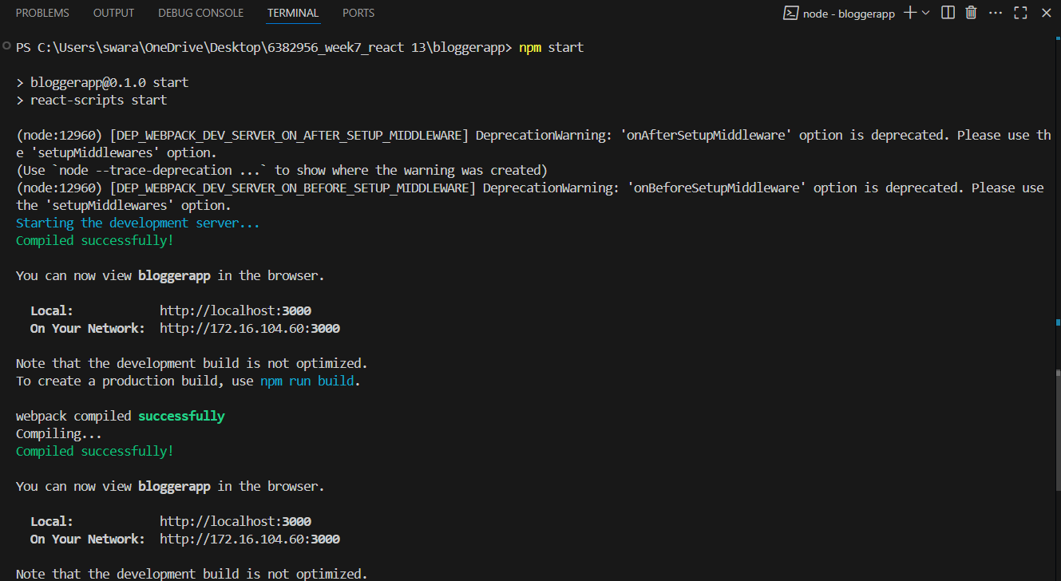

**Output 2:**

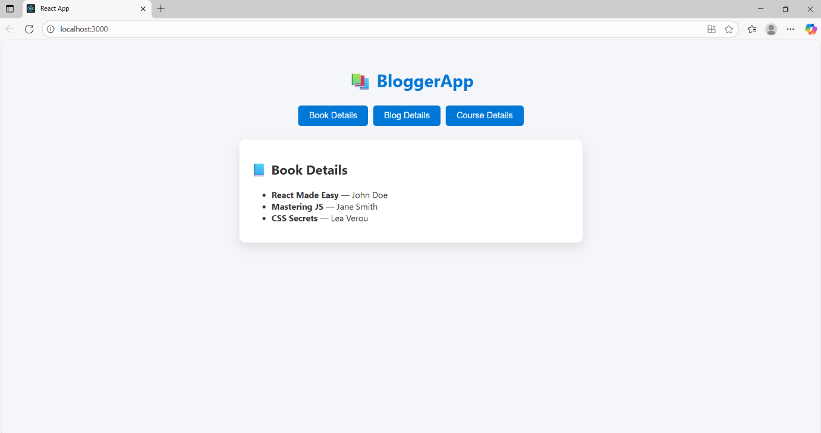

**Output 3:**

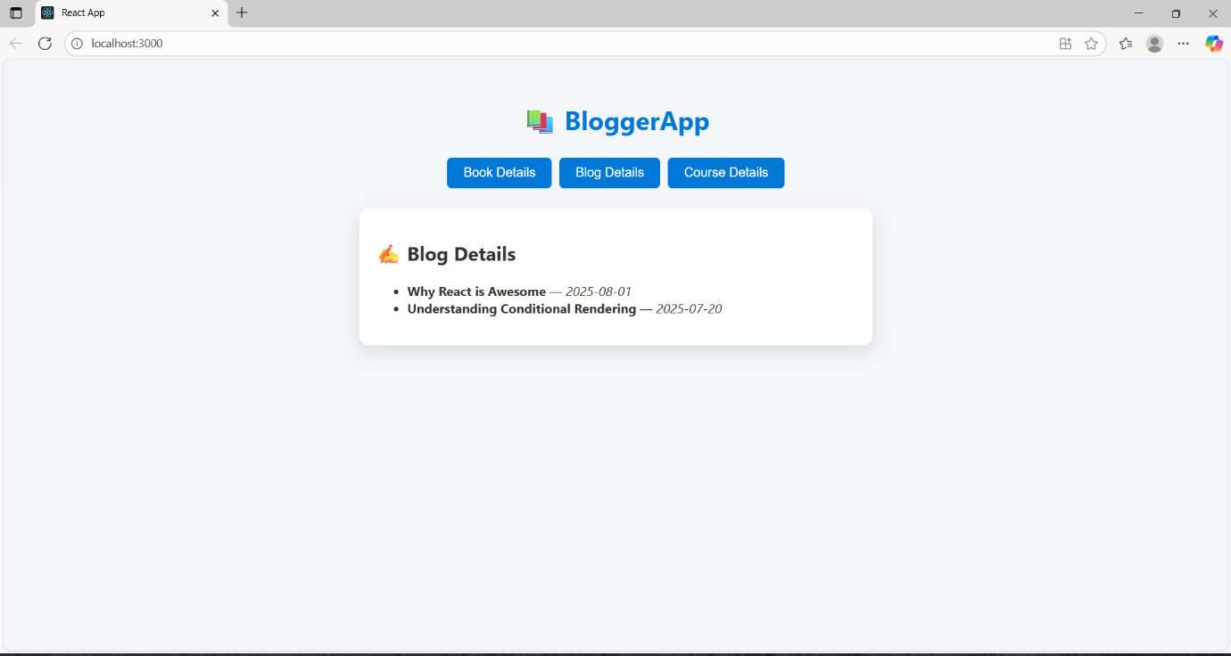

**Output 4:**

